
Air University Islamabad
FACULTY OF COMPUTING & ARTIFICIAL INTELLIGENCE
Department of Creative Technologies

Final Project

Statistics & Probability

BSDS

3
-
A

Submitted To: Sir Tahir Sher

Submitted By: Muhammad Abdullah Younas (232534),
Ayema Amir (232543)

Employee Attrition Dynamics

Exploring Trends, Patterns, and Predictive Factors

Employee retention is vital for organizational success. This project analyzes why employees leave, focusing on factors like job satisfaction, work-life balance, performance, and salary. Using statistical methods, we uncover patterns and trends, highlighting key drivers of attrition.
Our goal is to provide actionable insights to help organizations improve policies, boost employee satisfaction, performance and reduce turnover effectively.
Metadata:

Employee Table:
Column Name | Description
EmployeeID | Unique identifier assigned to each employee.
FirstName | The employee’s first name.
LastName | The employee’s last name.
Gender | The employee’s gender (e.g., Male, Female, Non-Binary).
Age | The employee’s age in years.
Business Travel | Indicates frequency of business travel (e.g., "Some Travel", "No Travel", "Frequent Travel").
Department | The department where the employee works (e.g., Sales, Human Resources, Technology).
Distance From Home (KM) | Distance in kilometers between the employee’s residence and the workplace.
State | The U.S. state where the employee is based.
Ethnicity | The ethnicity of the employee (e.g., White, Asian or Asian American).
Marital Status | Employee’s marital status (e.g., Single, Married, Divorced).
Salary | The employee’s annual salary in USD.
Stock Option Level | Level of stock options granted to the employee (0 = None, 1 = Low, 2 = Medium, 3 = High).
Over Time | Whether the employee works overtime (Yes/No).
Hire Date | The date the employee was hired.
Attrition | Indicates if the employee has left the company ("Yes" for attrition, "No" for active).
Years At Company | Total number of years the employee has been with the company.
Years In Most Recent Role | Number of years in their current role.
Years Since Last Promotion | Number of years since the employee’s last promotion.
Years With Curr Manager | Number of years the employee has worked with their current manager.

Performance Review Table:
Column Name | Description
Performance ID | Unique identifier for the performance review.
Employee ID | The employee’s unique identifier matching the Employee Table.
Review Date | Date of the performance review.
Environment Satisfaction | Employee’s satisfaction with the work environment (Scale: 1 = Low, 5 = High).
Job Satisfaction | Employee’s satisfaction with their job role (Scale: 1 = Low, 5 = High).
Relationship Satisfaction | Satisfaction with workplace relationships (Scale: 1 = Low, 5 = High).
Training Opportunities Within Year | Number of training opportunities provided to the employee within the year.
Training Opportunities Taken | Number of training opportunities taken by the employee.
Work Life Balance | Employee’s perceived balance between work and personal life (Scale: 1 = Poor, 5 = Excellent).
Self Rating | Employee’s self-assessment rating during the performance review (Scale: 1 = Low, 5 = High).
Manager Rating | The rating given by the manager during the performance review (Scale: 1 = Low, 5 = High).

Education Level Table:
Column Name | Description
Education Level ID | Unique identifier for different levels of education.
Education Level | Description of the education level, ranging from no formal qualifications to advanced degrees.

Rating Level Table:
Column Name | Description
Rating ID | Unique identifier for different performance rating levels.
Rating Level | Description of performance levels during evaluations, ranging from "Unacceptable" to "Above and Beyond".

Satisfaction Level Table:
Column Name | Description
Satisfaction ID | Unique identifier for different levels of satisfaction.
Satisfaction Level | Description of satisfaction levels, ranging from "Very Dissatisfied" to "Very Satisfied".

Visual Analysis of Employee Attrition: Key Questions, Concepts, and Insights

1. Attrition Rate Calculation:
Key Question: What is the proportion of active and inactive employees, and how does it reflect the overall attrition rate in the organization?
Concept: Basic probability and descriptive statistics.
- Probability: Calculating the proportion of employees who left (attrition rate).
- Descriptive Statistics: Summarizing the overall attrition rate for the company.
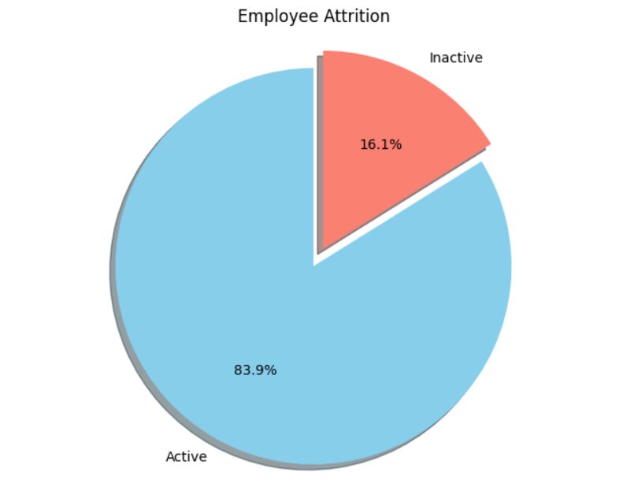
Insight: The analysis highlights that there is a "notable" attrition rate. This implies that the 16.1% rate is considered significant and potentially concerning.

2. Tenure and Attrition Correlation:
Key Question: Does the length of time an employee has been with the company affect their likelihood of leaving?
Concept: Correlation analysis (Inferential statistics).
- Correlation: Measuring the strength and direction of the linear relationship between employee tenure (years at the company) and attrition.
Insight: The analysis confirms that the length of time an employee has been with the company significantly influences their likelihood of leaving. Longer-tenured employees are more likely to stay, highlighting the importance of retention strategies focused on newer employees.
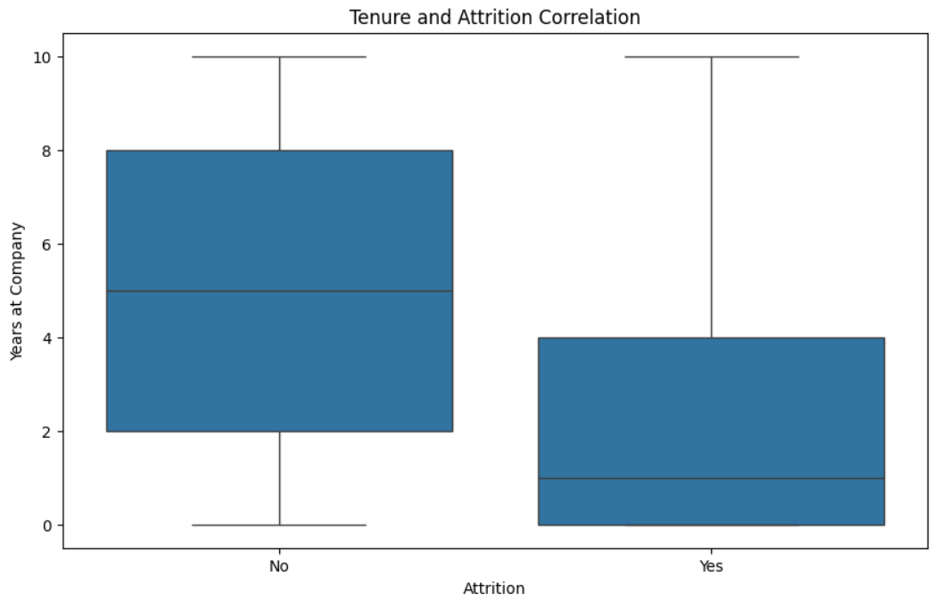
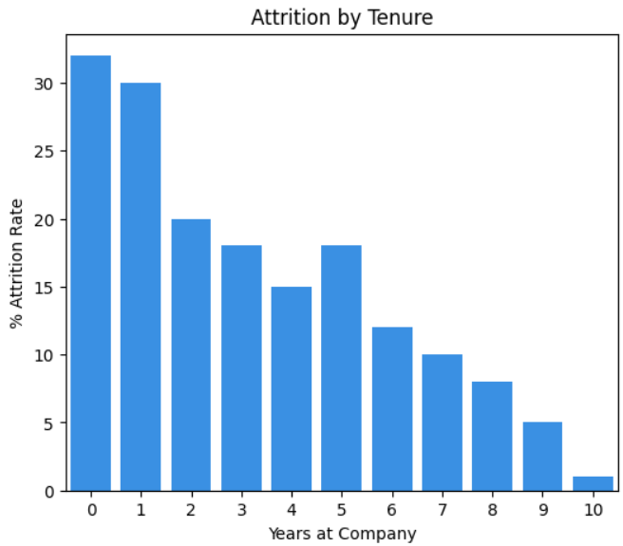

3. Salary and Attrition Correlation:
Key Question: If the company aims to reduce attrition, would increasing employee salaries be a potentially effective strategy?
Concept: Correlation analysis (Inferential statistics).
- Correlation: Assessing the relationship between employee salary and attrition.
Insight: A weak negative correlation between salary and attrition, implying that higher salaries might slightly reduce attrition, it's crucial to acknowledge that salary might not be the primary factor influencing employee turnover. A comprehensive strategy addressing various employee needs and concerns is recommended for effective attrition reduction.
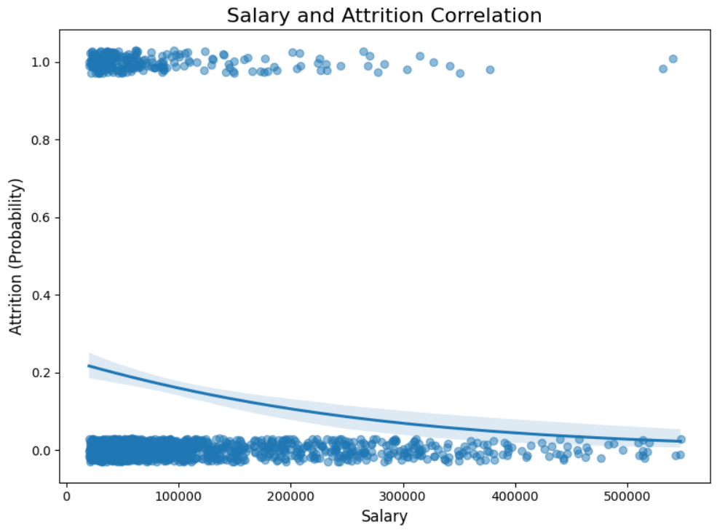

4. Departmental Differences in Attrition and Retention:
Key Question: Is an employee's department, a factor in their likelihood of leaving the company?
Concept: Descriptive statistics and conditional probability.
- Descriptive Statistics: Comparing attrition rates and retention probabilities across different departments (e.g., Technology, Human Resources).
- Conditional Probability: Implicitly calculating the probability of attrition or retention given a specific department.
Insight: The Sales department, particularly the Sales Representative role, exhibits the highest attrition rates, while the Technology department shows relatively balanced attrition across technical roles. These insights highlight the importance of considering departmental factors when developing retention strategies and understanding employee turnover patterns.

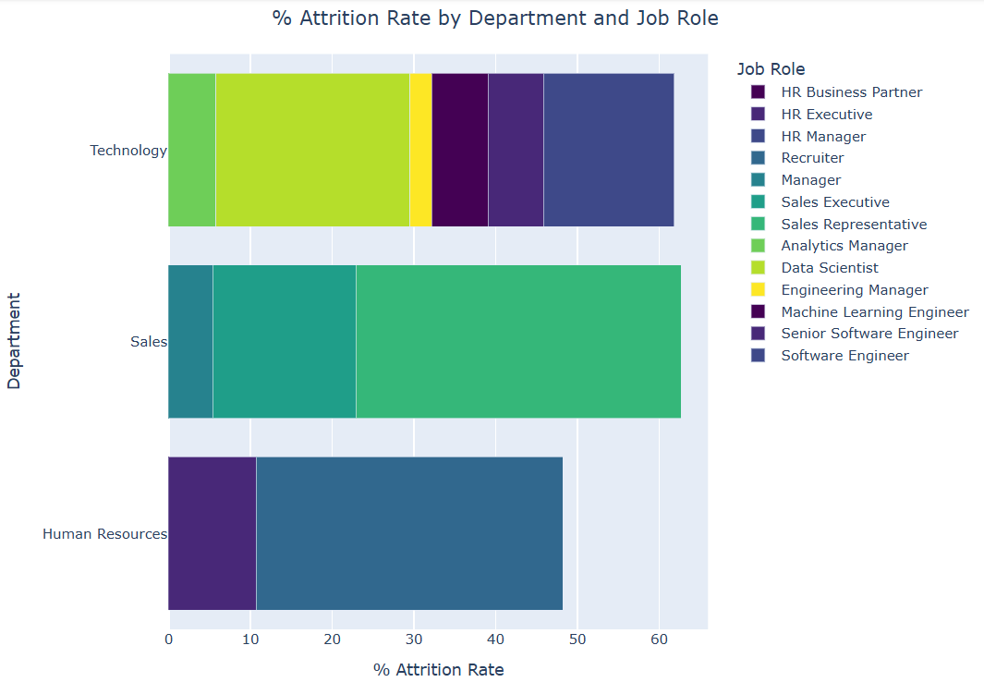

5. Active Employees by Department and Job Role
Key Question:
How are active employees distributed across different departments and job roles?
Concept:
Descriptive Statistics: Summarizes the number of active employees in each department and job role, providing insights into workforce composition across different areas.
Insight: The Technology department has the most active employees, with Software Engineers leading the count, while Human Resources has the fewest active employees across its roles.

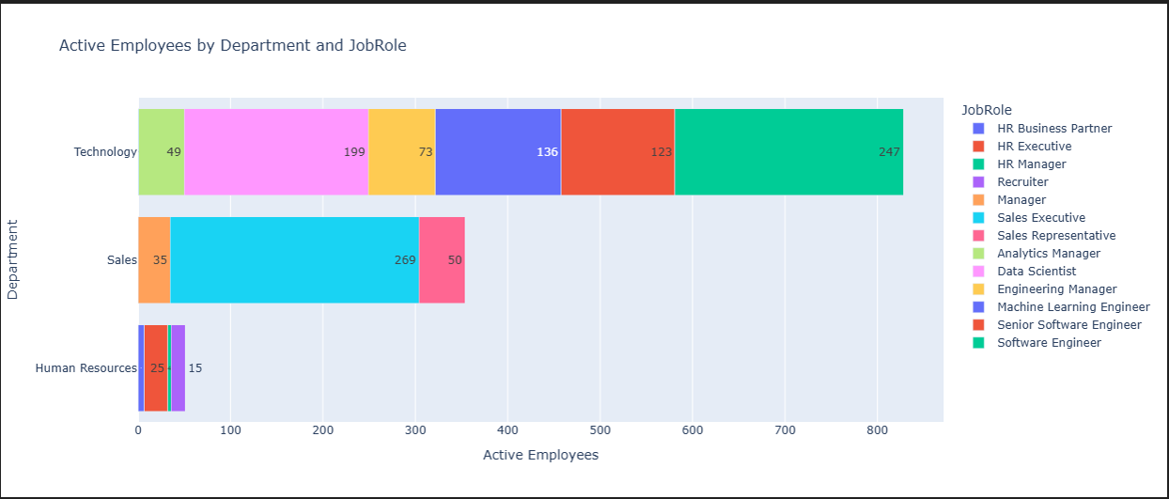

6. Performance Analysis:
Key Question: Analyze the impact of different factors on employee performance. Which features have the most significant influence on performance predictions?
Concept: Regression analysis (Inferential statistics) and feature importance.
- Regression: Using a regression model (e.g., linear regression) to predict performance based on selected features.
- Feature Importance: Identifying the features that have the most significant impact on performance predictions (e.g., using random forest regressor).
Insight Salary is the most critical predictor of employee performance ratings, followed by Years at Company, Job Satisfaction, Work-Life Balance, and Environment Satisfaction. By understanding and addressing these factors, organizations can effectively improve employee performance and overall productivity.

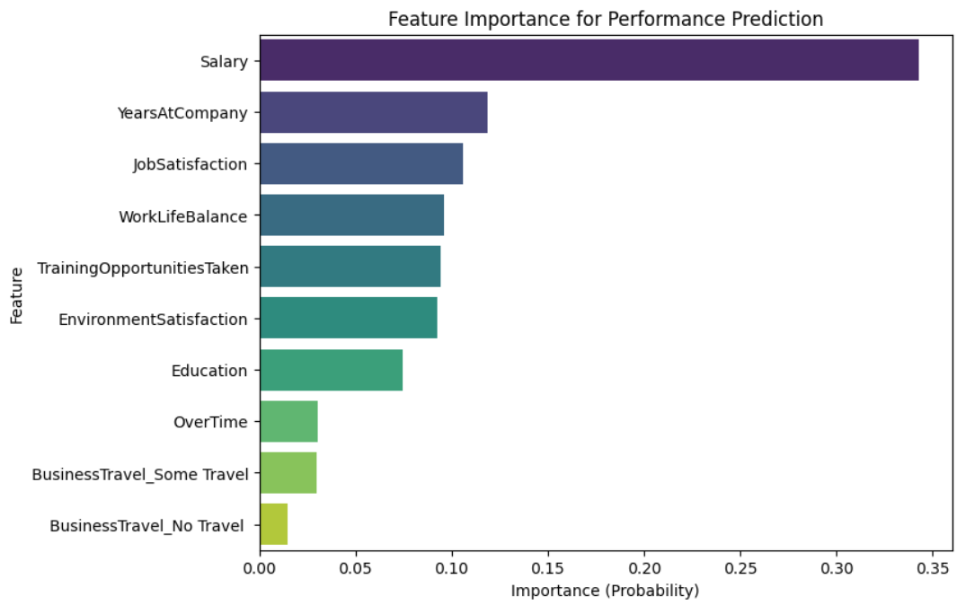

7. Overtime and Attrition:
Key Question: Investigate the relationship between overtime and attrition. Does working overtime make employees more likely to leave?
Concept: Conditional probability and descriptive statistics.
- Conditional Probability: Calculating the probability of attrition given that an employee works overtime.
- Descriptive Statistics: Comparing attrition rates between employees who work overtime and those who don't.
Insight: Employees working overtime are more likely to leave the organization. Organizations should carefully consider the implications of overtime practices on employee retention and implement strategies to address the potential risks.
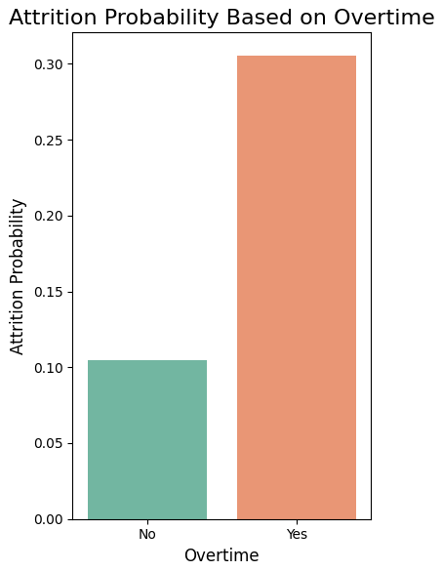

8. Hiring Trends and Attrition Probability:
Key Question: Investigate the relationship between hiring year and attrition probability. Have there been periods with unusually high or low attrition among employees hired in certain years?
Concept: Time series analysis and descriptive statistics.
- Time Series Analysis: Analyzing the trend of attrition probability over time (by hiring year).
- Descriptive Statistics: Calculating and summarizing attrition probabilities for different hiring years.

Insight:
The total number of active employees ("No Attrition") has remained significantly higher and more stable over the years compared to the relatively low and consistent number of attrited employees ("Yes Attrition").
The probability of attrition fluctuates over the years, with noticeable peaks in 2016 and 2020, indicating higher attrition rates for employees hired in those years compared to other years. Understanding the specific factors contributing to these peaks is crucial for developing targeted retention strategies and mitigating future attrition risks.
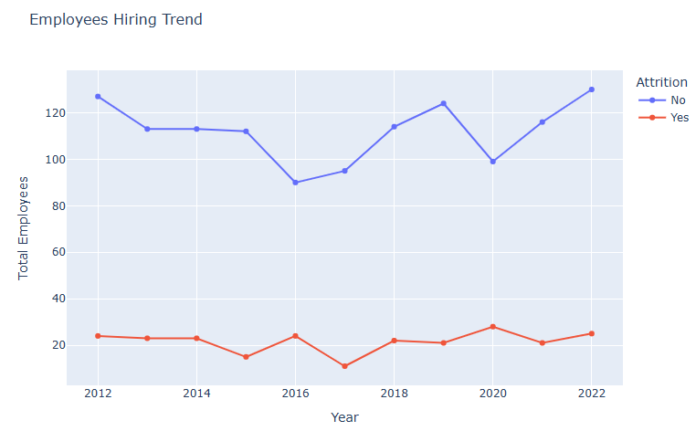
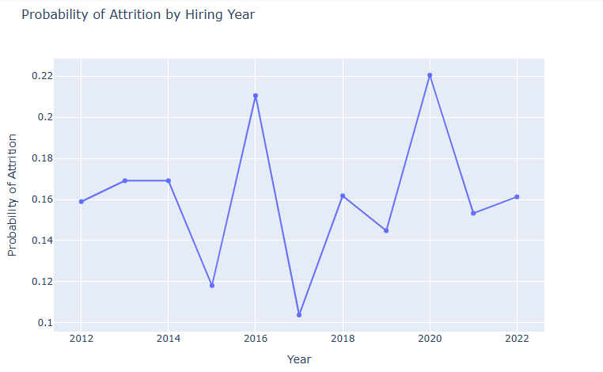

9. Employee Demographics and Distributions:
Key Question: Analyze the demographic distribution of employees, including marital status, age, gender, and ethnicity.
Concept: Descriptive statistics and data visualization.
- Descriptive Statistics: Calculating frequencies and percentages for different demographic categories.
- Data Visualization: Using charts (e.g., pie charts, bar charts) to visually represent the distribution of employees across demographic groups.
Insights:
- Married employees are more ,42.4%
- The majority of employees are in the 20–29 age group, with a higher representation of males, while older age groups have progressively fewer employees and more balanced gender distributions.
- White employees have the highest average salary and total number of employees, while other ethnic groups show significant variation in both metrics.
The analysis provides a comprehensive understanding of the demographic distribution of employees, highlighting key trends and variations across marital status, age, gender, and ethnicity. These insights are valuable for workforce planning, diversity and inclusion initiatives, and compensation strategies.
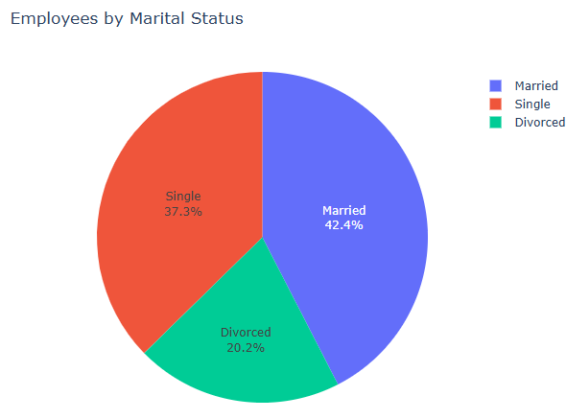

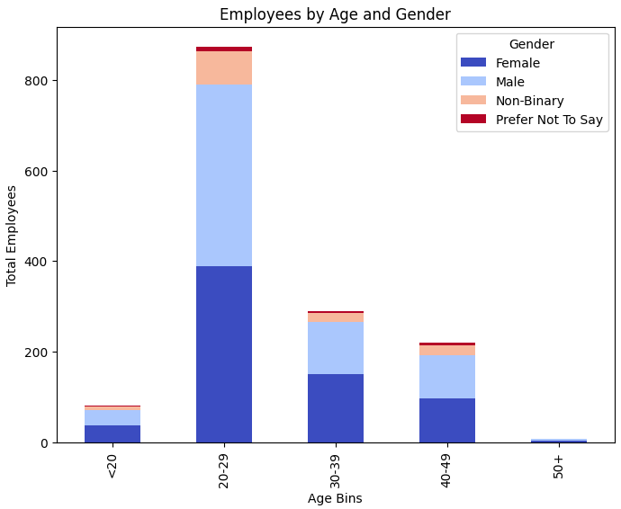

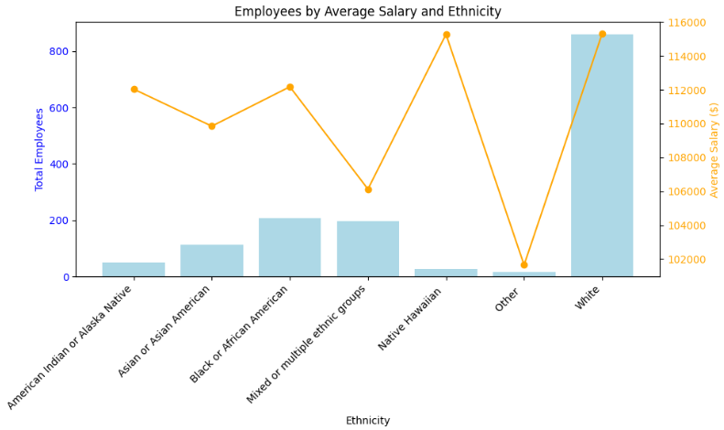

10. Travel Frequency and Attrition:
Key Question: Compare the attrition rates of employees across different travel frequency categories (e.g., Non-Travel, Travel_Rarely, Travel_Frequently).
Concept: Conditional probability and descriptive statistics.
- Conditional Probability: Calculating the probability of attrition given different levels of travel frequency.
- Descriptive Statistics: Comparing attrition rates between groups with different travel frequencies.
Insight: Employees who travel frequently for business exhibit the highest attrition rates, while those with no travel have the lowest attrition rates. Companies should address these factors to improve retention among frequent travelers.
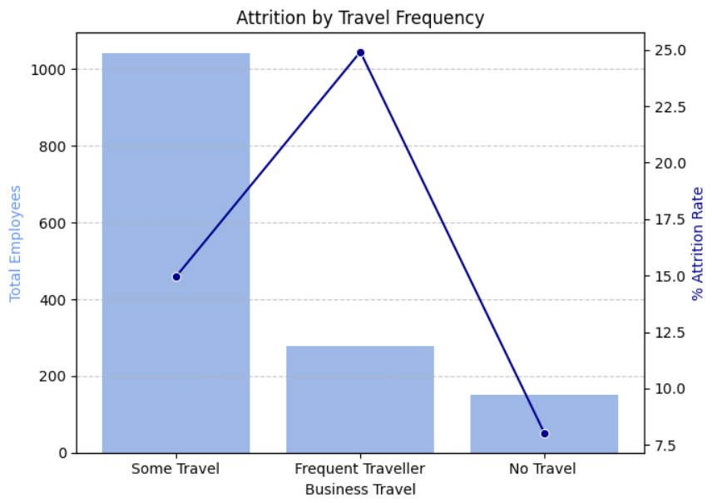

11. Promotion Analysis:
Key Question: How likely are employees to get promoted in different departments, based on their performance ratings, training opportunities, and years at the company?
Concept: Correlation analysis, logistic regression, conditional probability and descriptive statistics.
- Correlation: Assessing the relationship between performance ratings and promotion outcomes.
- Logistic Regression: Potentially using logistic regression to model the probability of promotion based on performance and other factors.
- Descriptive Statistics: Calculating promotion rates for different performance levels.
- Conditional Probability: Calculates the probability of promotion given certain conditions (e.g., high performance).

Insight:
- The heatmap shows a strong link between self and manager ratings (0.85), a negative relationship between promotion likelihood and tenure (-0.64), and weak or no impact of ratings or training on promotions.
- Human Resources has the highest promotion rate, followed by Sales, with Technology having the lowest.
- Manager ratings are similar for promoted and non-promoted employees, indicating ratings may not heavily influence promotions.
- Employees are either promoted early or stay in the same position for a long time, suggesting a lack of promotions in the middle years.

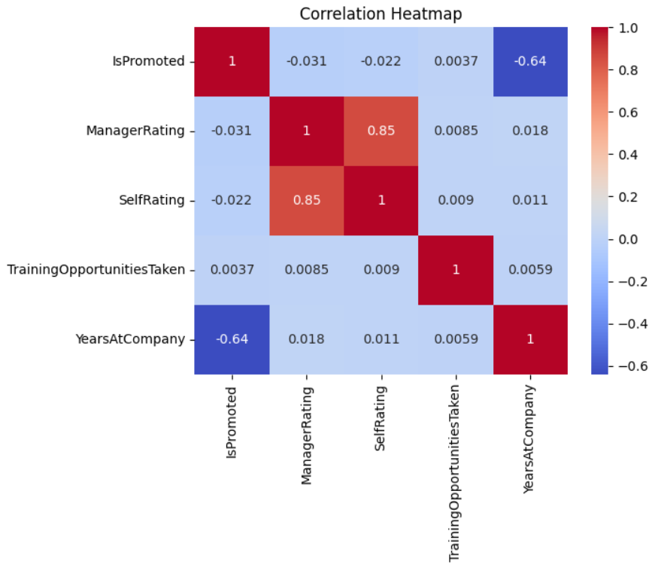
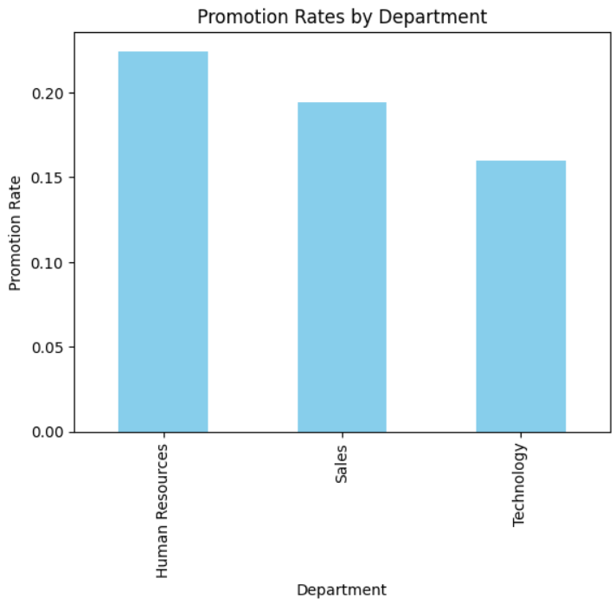
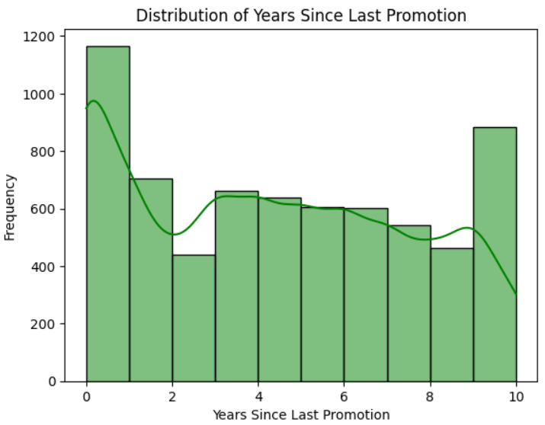

12. Analysis of Employee Attrition, Job Satisfaction, Work-Life Balance, Salary, and Tenure
Key Question: How are employee attrition, job satisfaction, work-life balance, salary, and years at the company correlated with each other?
Concept: Correlation analysis and Quantitative Analysis
- Correlation analysis: Examines the strength and direction of relationships between numeric variables, identifying patterns like how job satisfaction affects attrition or tenure correlates with salary.
- Quantitative analysis: Uses binary coding to convert categorical variables like "Attrition" and "Over Time" into numerical values for statistical analysis.

Insight: Attrition is negatively correlated with years at the company (-0.69) and salary (-0.21), indicating that employees with longer tenures or higher salaries are less likely to leave. Job satisfaction and work-life balance show little to no significant correlation with attrition, suggesting that retention strategies should prioritize tenure-building and competitive compensation.

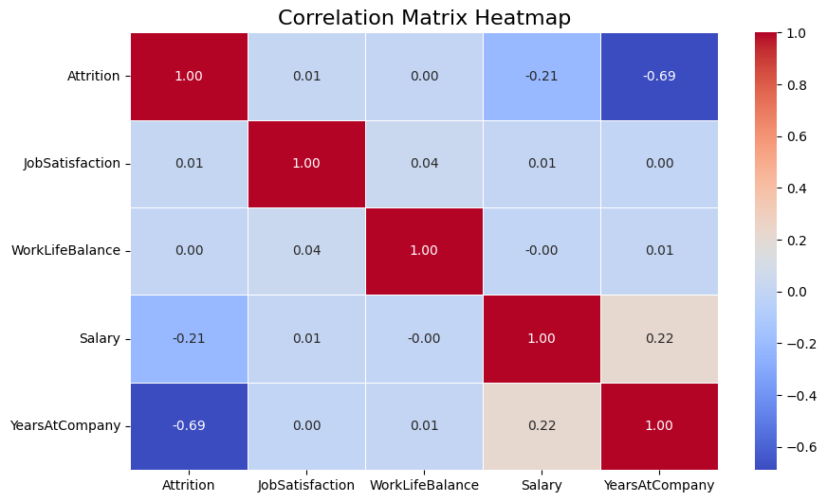

Suggestions for the Company
- Improve Job Satisfaction: Enhance work-life balance, provide career development opportunities, and address departmental needs to boost retention.
- Refine Compensation and Overtime: Offer competitive salaries and reduce overtime to prevent burnout and improve employee satisfaction.
- Target High-Attrition Areas: Focus retention strategies on roles and departments with high turnover, like Sales and frequent travelers.
- Promote Inclusivity: Use demographic insights to strengthen diversity and inclusion while catering to the unique needs of different employee groups.
- Leverage Data Insights: Continuously analyze workforce data to adapt policies, refine hiring processes, and address attrition trends effectively.

